OBC Selection Proposal

# OBC/Microcontroller

## Microcontroller type

The goal when selecting the microcontroller for the OBC is to be able to implement a prototype that can deliver **maximum processing capability** while using a **minimum of power** and being capable of accomplishing all the required **OBC functions**, mainly the execution of **programs** and **commands** with a **minimum response time**.

The usual choices in selecting a microcontroller type are 8,16 or 32-bit. Looking at many examples of CubeSat missions as well as the Perseverance rover, it seems that 32-bit is a suitable and commonly used option as it will be able to handle multiple peripherals.

## Memory

For a space mission, the OBC will most likely require both volatile and non-volatile memory. In seeing the type of non-volatile memory, the mission requires, the size, power consumption, price and durability need to be considered. Memory size is important because memory is used to store software for the operations as well as data gathered by sensors or other subsystems. However, the internal memory of a microcontroller is usually small, and the application will require an external memory module. The non-volatile memory types I have looked at were flash memory and EEPROM. Flash uses NAND-type memory while EEPROM uses NOR-type. NOR-type memory has a slower write and erase speed but has a faster read speed compared to NAND-type. Since the OBC will be needing to send data to the station and perhaps even in a short time frame, a microcontroller using EEPROM (NOR-type memory) will be more suitable.

For volatile memory, we can either choose SRAM or DRAM. Since SRAM is generally a newer and better type of volatile memory, it will be suitable for our application. Size may be a constraint as SRAM takes up more space, but hopefully this should not be a problem.

## Operating temperature range

Titan has very cold conditions. According to the final report, the minimum temperature that can be reached is around -201 degrees Celsius and the maximum could be around no more than -100 degrees Celsius. Assuming we have a solid thermal subsystem in place, our microcontroller will hopefully not get too cold and will be able to operate in a reasonable temperature range such as -40 to 125 degrees Celsius for example.

## Operating voltage

Most 32-bit controllers typically run on 2.2 to 3.6 volts so are microcontroller will most likely be one of the two.

Some of the microcontrollers I’ve found online included nine 16-bit digital timers, 64 pins, 200 MHz clock speed, 512 kB of RAM and 2048 kB of program memory size.

# Data Handling

## Data Handling Unit

The data handling unit will consist of a memory card, router card and a transmitter. The memory card will contain an external memory module which will store the main data obtained from the OBC coming from sensors and other subsystems. This is where the OBC sends its data to. The router card will be responsible for distributing data to necessary subsystem such as the actuators of the attitude determination and control system. Lastly, the transmitter will be responsible for sending carrying out telemetry and teleoperation tasks to communicate with the station

## Data Storage – External Memory Module

On-chip memory is usually insufficient with the amount of data we will be working with so an external memory device will be needed. I had a look at using EEPROM, but this type of memory is useful for small applications such as the internal memory of a microcontroller. For external memory, an SD card will probably more suitable as they can store a lot more data and come in range of sizes.

## Telemetry and Teleoperation

I will be assuming that there will be a satellite orbiting around Titan which will act as the target for our communications. There are four data link protocols that I have looked at – TM Space Data Link Protocol, TC Space Data Link Protocol, AOS Space Data Link Protocol and Proximity-1 Space Link Protocol. TM is usually used for sending telemetry from a spacecraft to a ground station while TC is the opposite. AOS can be used for both if a two-way higher-speed communication is required. However, the Proximity-1 Space Link Protocol can be used over proximity space links which are defined to be short range, bi-directional, fixed, or mobile radio links. This protocol is used for fixed probes, landers, rovers, and orbiting relays and so it seems like a suitable protocol to use.

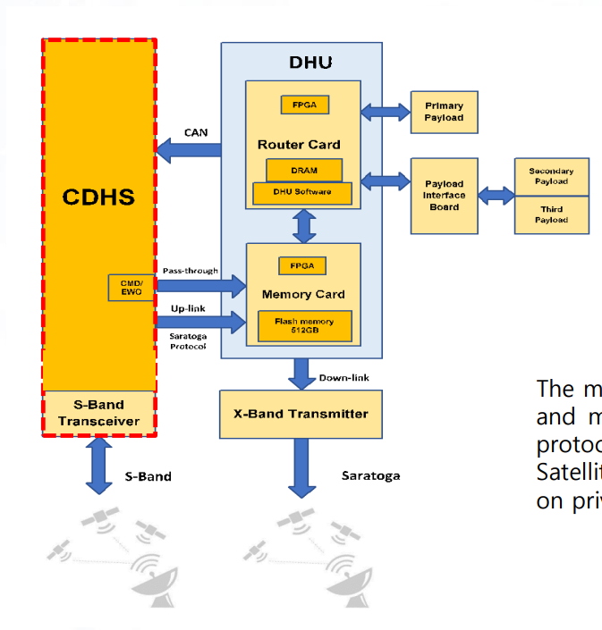

# Operational Modes

“A multi-loop controller is an electronic device used in a closed loop system to read multiple input values from a number of measuring devices and provide controlled outputs to achieve”. This looks like a very suitable choice for our OBC as we will be dealing with many sensors and thus inputs at the same time. For example, the ADCS will many sensors providing details about the orientation of the spacecraft and so a multi-loop controller will provide a great foundation for this application.

I have not personally dealt with timers properly and am just starting to learn about control methods. I’ve read up on timers, but I didn’t mention any of that here.

# OS

Our application will be real-time and so a real-time operating system will most likely need to be used. The two most common operating systems that have been used are RTEMS and VxWorks. Apparently, ESA has worked with VxWorks while NASA commonly uses RTEMS for example for the Mars Reconnaissance Orbiter. However, VxWorks was used for the Mars Curiosity Rover and the InSight Spacecraft that landed on Mars. The system must react to things with extreme precision making adjustments based on real-time readings and VxWorks seems to be a suitable RTOS for this application.